Maynard Hebert – Speaker Media Kit
Building Trust, Grit, and Real Teams.

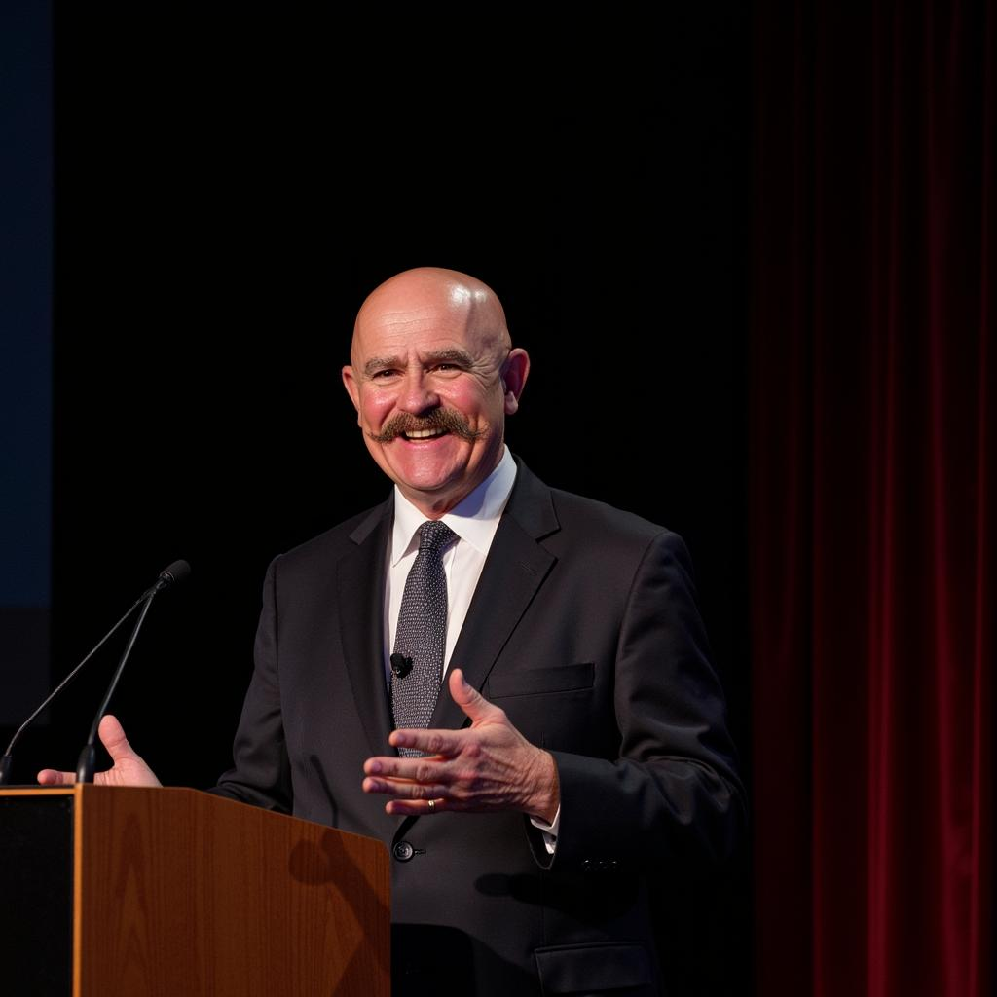

Short Bio
Maynard Hebert – Author of Onward Buttercups, Professional Speaker, and Host of Gears of Trust
Maynard Hebert is a seasoned heavy-duty mechanic, unapologetic truth-teller, and professional speaker who brings decades of leadership experience from Canada’s oil sands to the stage. Recognized as Mader Mining’s 2024 Outstanding Employee of the Year, Maynard blends grit, humor, and real-world wisdom to challenge how organizations think about trust, culture, and teamwork. Through his book Onward Buttercups, his uncensored podcast Gears of Trust, and his engaging keynotes, Maynard helps leaders and crews alike create workplaces that are more productive, respectful, and worth showing up for.

Long Bio
I’m Maynard Hebert, and I’ve spent my life in the trenches—first as a heavy-duty mechanic, then as a no-nonsense supervisor, small business owner, and now, as a speaker and author. I was raised with a baby boomer work ethic and an old-school belief system, back when a handshake meant something and teamwork was survival. Over the years, I’ve seen workplaces thrive and I’ve seen them fall apart. What I’ve learned is simple: when trust breaks, everything breaks.
That’s why I host Gears of Trust, a podcast where I dive into the raw and often uncomfortable conversations about workplace culture, leadership, and employee relations. No sugarcoating—just straight talk, a little irreverence, and a lot of focus on real solutions.
I also wrote Onward Buttercups, a no-nonsense guide to teamwork and leadership that strips away the fluff and gets down to what really works. Now, I’m bringing those lessons to the stage as a keynote speaker, sharing stories and strategies that are equal parts gritty, funny, and practical. In 2024, I was honored as Mader Mining’s Outstanding Employee of the Year, recognition of not just my technical skills, but my ability to bring crews together and strengthen teams from the inside out.
And I’m not stopping there—I’m building a self-learn online course to give people the tools to make their workplaces happier, more productive, and a whole lot less frustrating. Because I believe work should be more than just a paycheck. It should be a place where people feel valued, respected, and even enjoy what they do.
At the end of the day, my mission is to bridge the gap between management and workers—one brutally honest story, one keynote, and one conversation at a time.

Ultra-Short Bios
General Use:
Maynard Hebert is the author of Onward Buttercups, host of the Gears of Trust podcast, and a professional speaker. Named Mader Mining’s 2024 Outstanding Employee of the Year, he shares gritty, funny, and practical lessons on leadership—building trust, grit, and real teams.
Social Media Friendly:
Author. Speaker. Truth-teller. 🎤 Maynard Hebert—host of Gears of Trust and author of Onward Buttercups—is on a mission to build trust, grit, and real teams.
Speaker Reel/Tagline Style:
Maynard Hebert—Author of Onward Buttercups, award-winning mechanic, and host of Gears of Trust. On stage, he blends grit, humor, and honesty—building trust, grit, and real teams.

Keynote Themes
- Building Trust, Grit, and Real Teams
- Leadership that Listens
- Bridging the Gap Between Management and Workers
- Culture Without the Corporate Fluff

 | 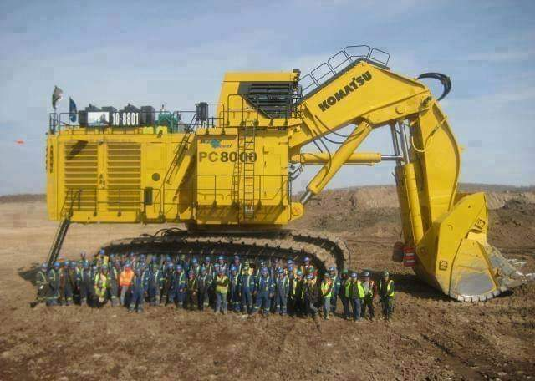
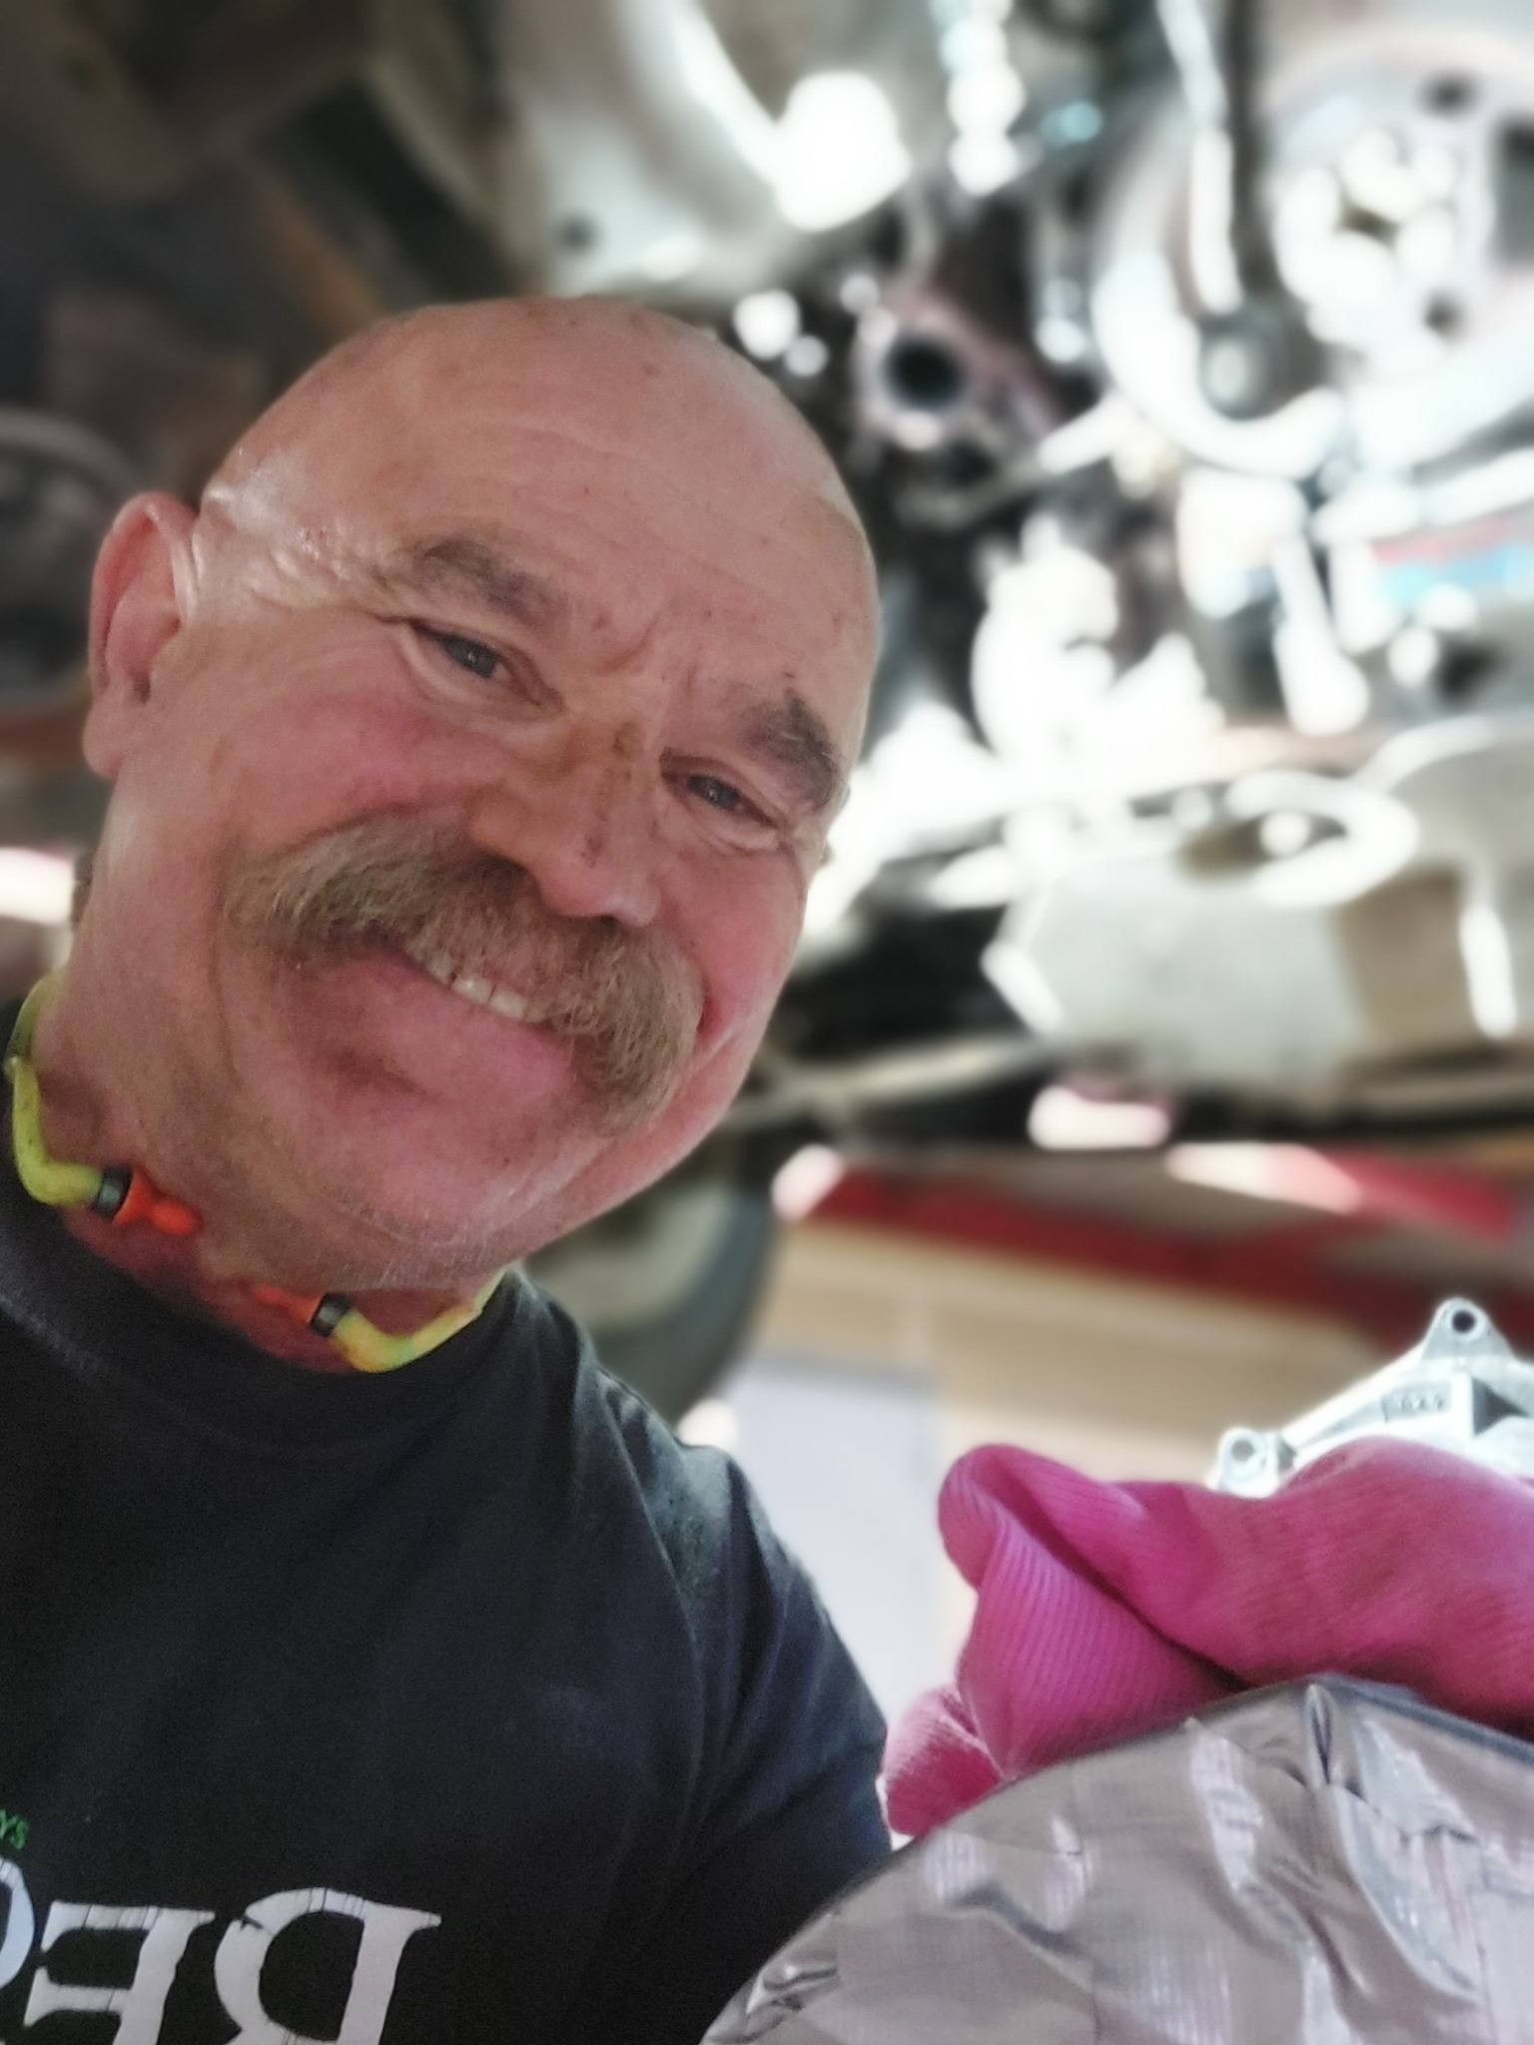

Contact
Website: www.maynardhebert.com
Email: maynard@maynardhebert.com

